CSA1708 – ARTIFICIAL INTELLIGENCE LAB EXPERIMENTS

Program 11: Map Coloring using CSP

Aim
To develop a Python program to solve the Map Coloring Problem using a Constraint Satisfaction Problem (CSP) by assigning different colors to adjacent regions.

Algorithm
- Define the regions and their neighboring regions.
- Define the available colors.
- Select a region.
- Assign a color to the selected region.
- Check whether neighboring regions have different colors.
- If the color is valid, move to the next region.
- If no valid color is available, backtrack.
- Display the final color assignment.
Program
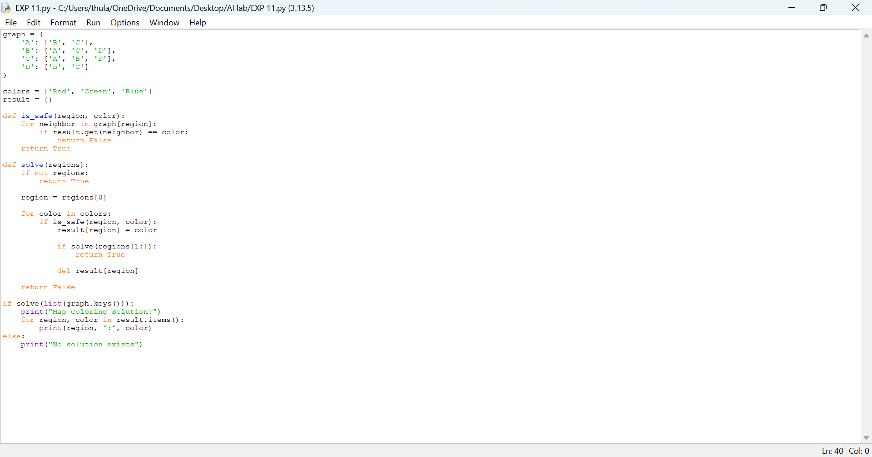

Output
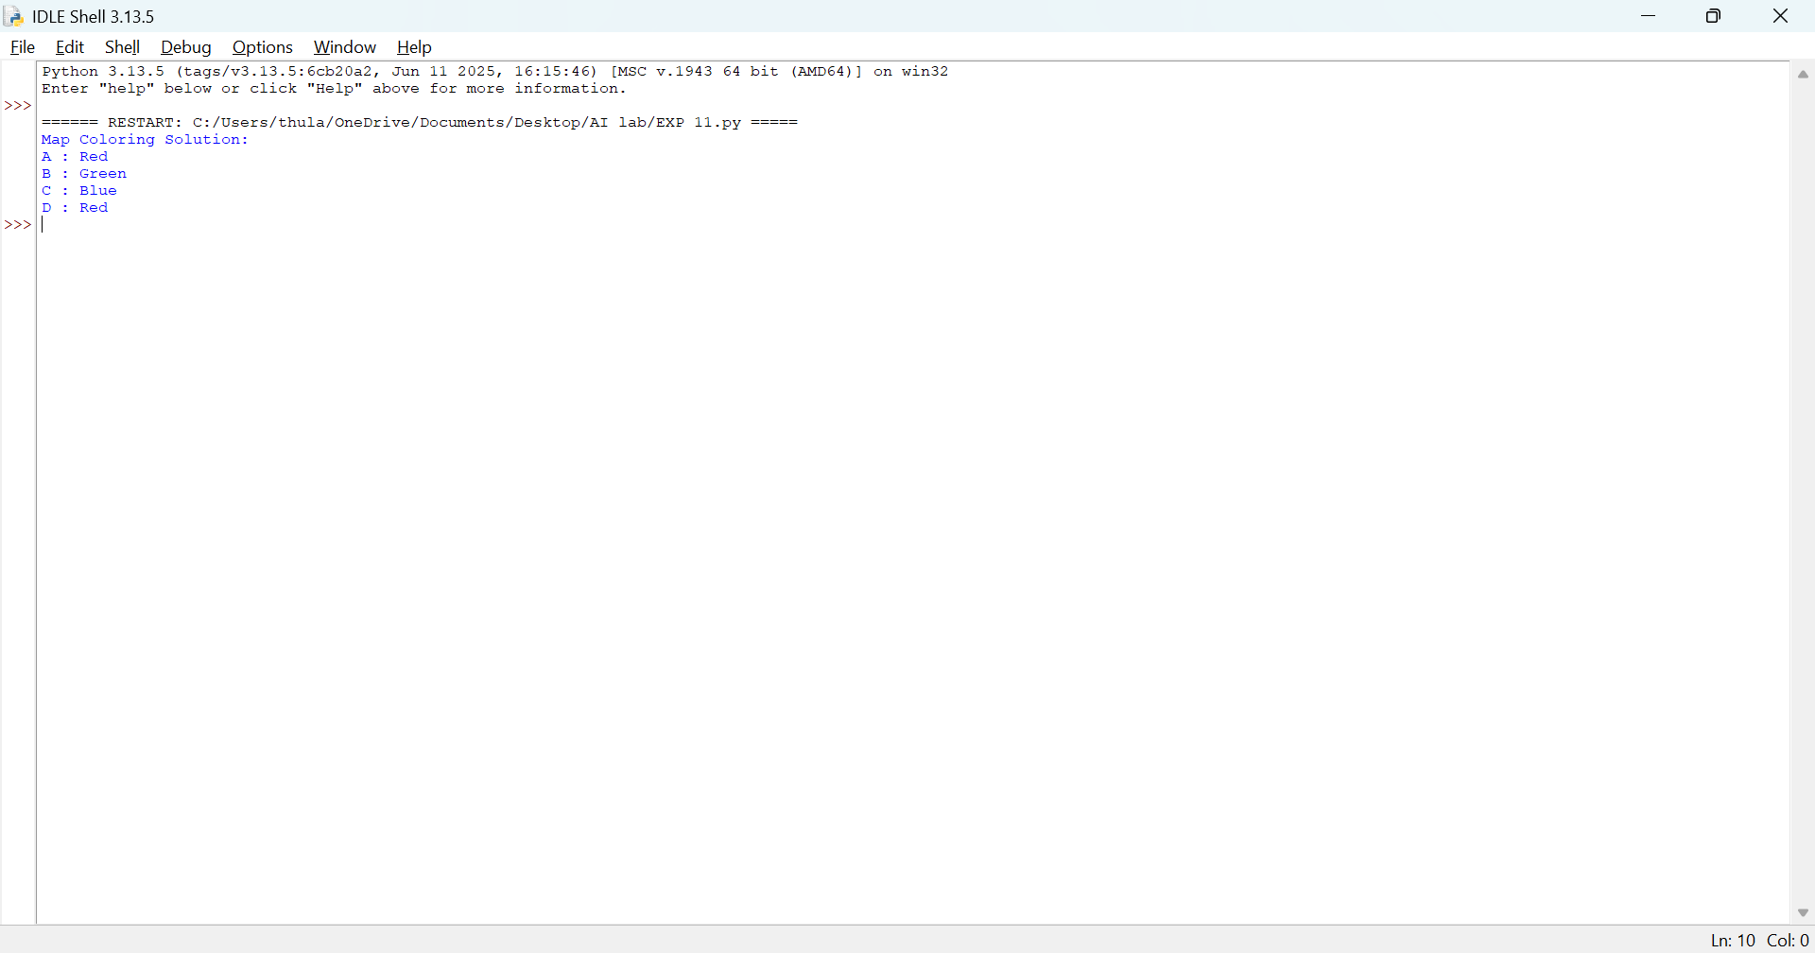

Result
Thus, the Map Coloring Problem was solved successfully using Python and the CSP technique.

Program 12: Tic-Tac-Toe Game

Aim
To develop a Python program to implement the Tic-Tac-Toe game between two players using a 3×3 board.

Algorithm
- Create a 3×3 game board.
- Assign X and O to two players.
- Display the board.
- Ask the current player to enter a position.
- Check whether the position is empty.
- Update the board with the player's mark.
- Check for a winning combination or a draw.
- Repeat until a player wins or the game ends in a draw
Program
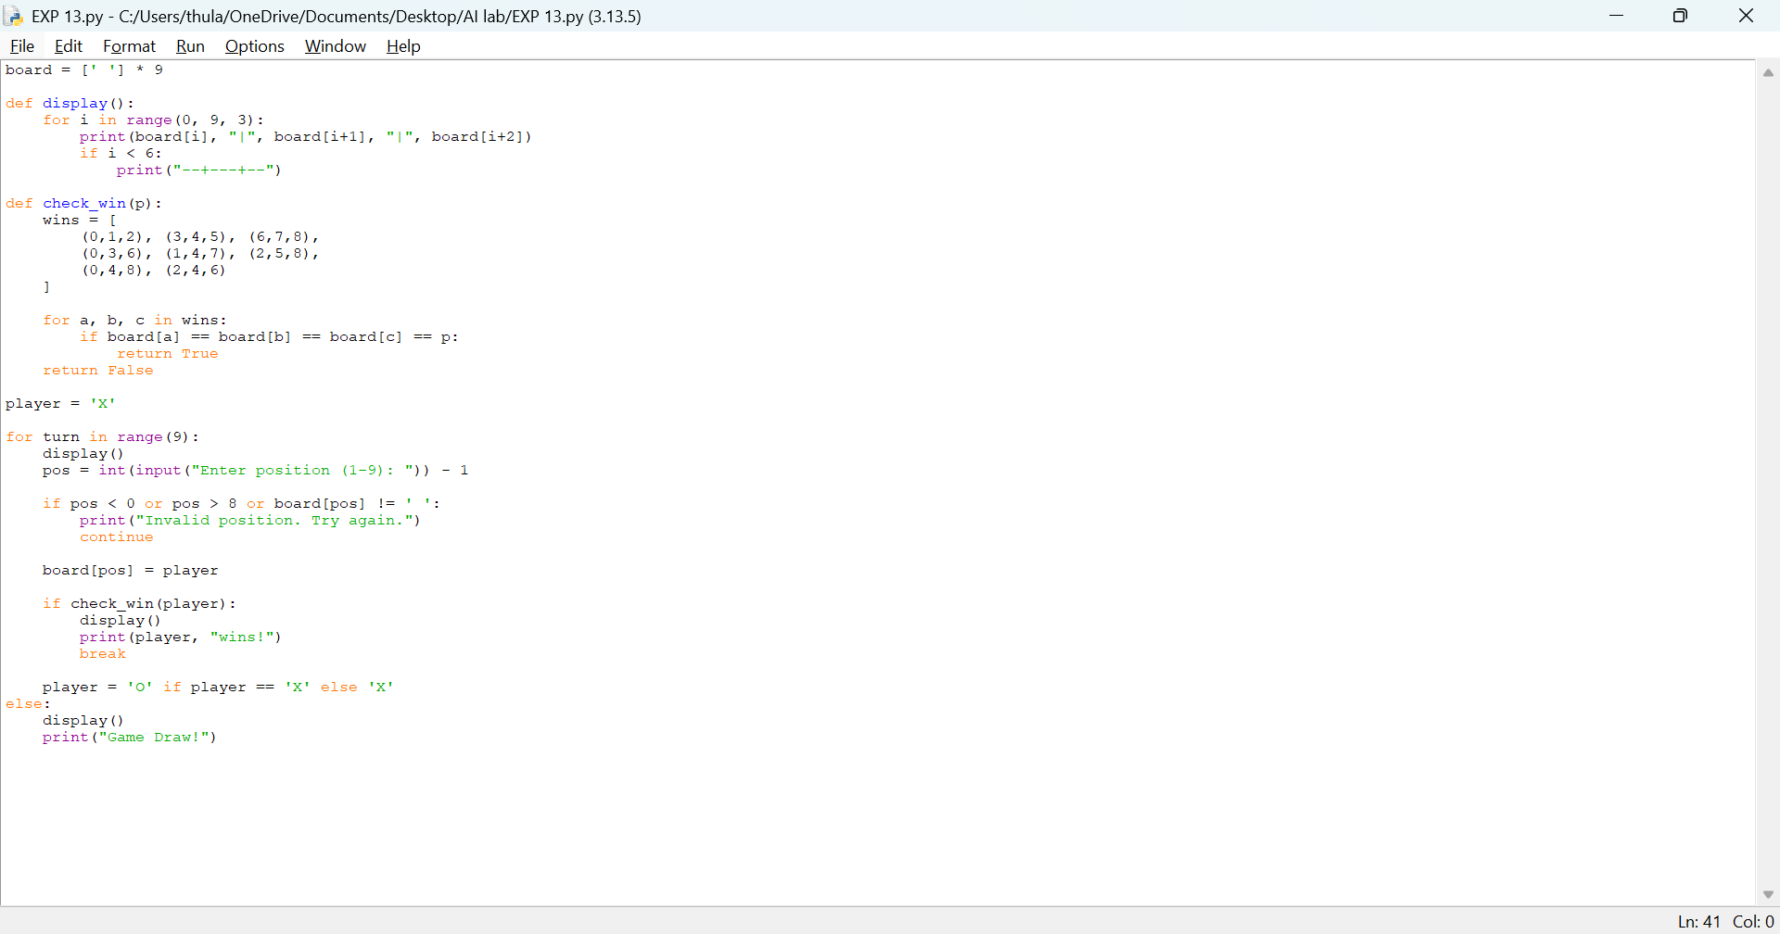

Output
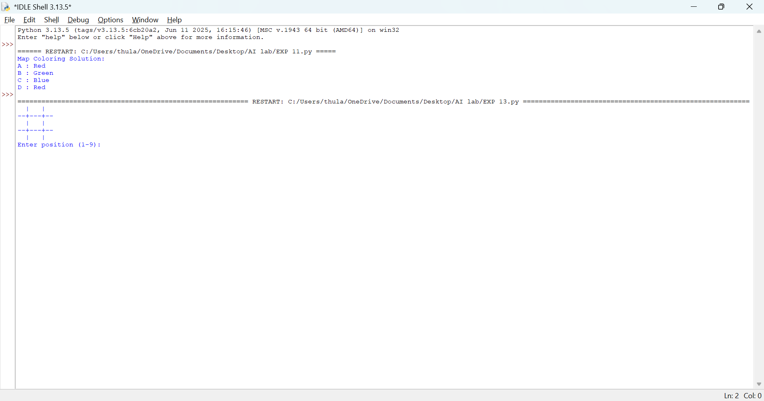

Result
Thus, the Tic-Tac-Toe game was implemented successfully using Python

Program 13: Minimax Algorithm for Gaming

Aim

To develop a Python program to implement the Minimax algorithm for selecting the best move in a game.

Algorithm
- Define the game tree.
- Assign utility values to the leaf nodes.
- Maximize the score at MAX nodes.
- Minimize the score at MIN nodes.
- Evaluate the game tree recursively.
- Select the move with the best score.
- Display the optimal score.
Program
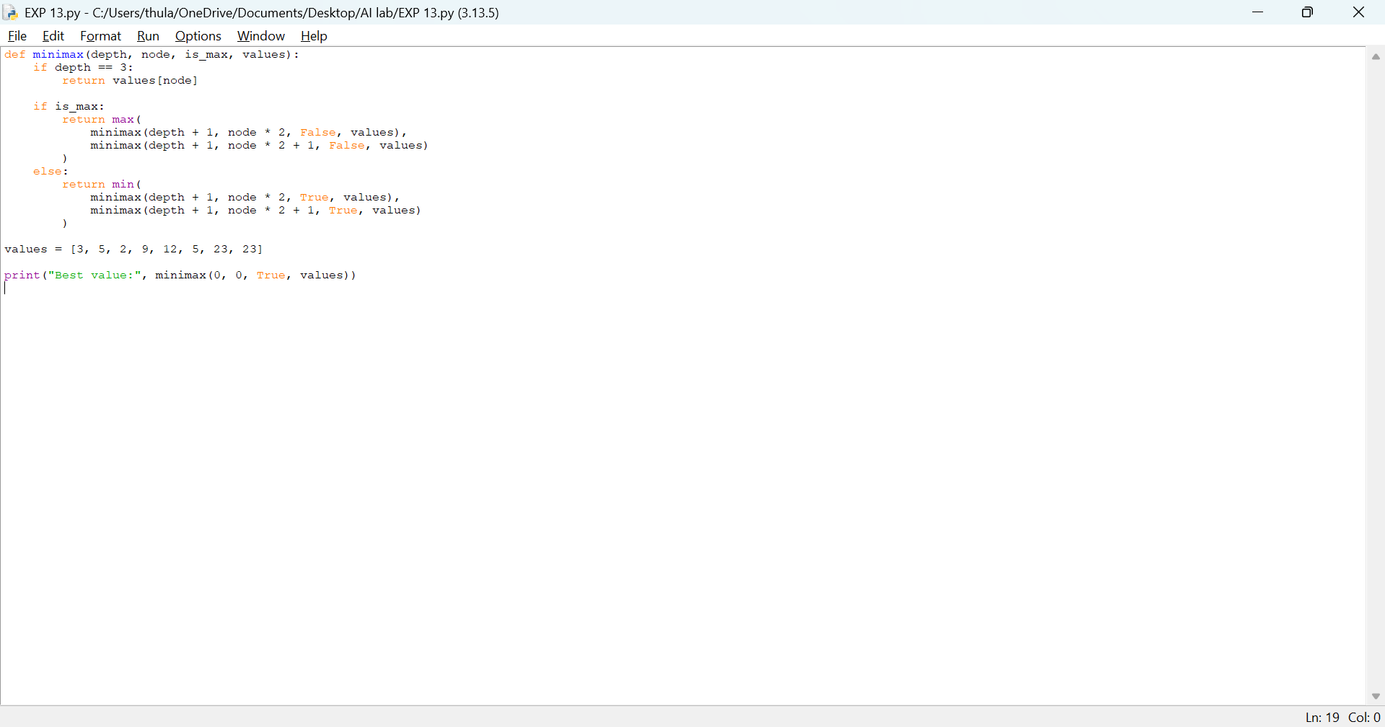

Output

Result
Thus, the Minimax algorithm was implemented successfully to determine the best value in a game tree.

Program 14: Alpha-Beta Pruning Algorithm for Gaming

Aim
To develop a Python program to implement the Alpha-Beta Pruning algorithm to optimize the Minimax search by eliminating unnecessary branches.

Algorithm
- Define the game tree and leaf values.
- Initialize alpha to negative infinity and beta to positive infinity.
- Evaluate MAX nodes by selecting the maximum value.
- Evaluate MIN nodes by selecting the minimum value.
- Update alpha and beta values during traversal.
- Stop exploring a branch when alpha is greater than or equal to beta.
- Display the best value.
Program
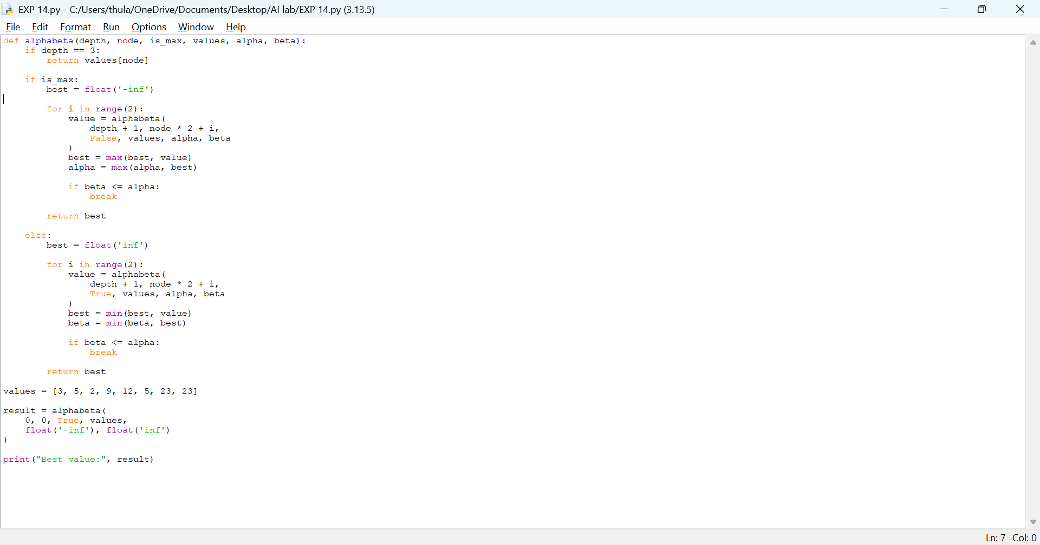

Output

Result
Thus, the Alpha-Beta Pruning algorithm was implemented successfully to find the best game value while pruning unnecessary branches.

Program 15: Decision Tree

Aim
To develop a Python program to implement a Decision Tree classifier for predicting outcomes based on input features.

Algorithm
- Import the required libraries.
- Create a sample dataset with input features and output labels.
- Separate the input features and target labels.
- Create a Decision Tree classifier.
- Train the classifier using the dataset.
- Predict the output for a new input.
- Display the prediction.
Program
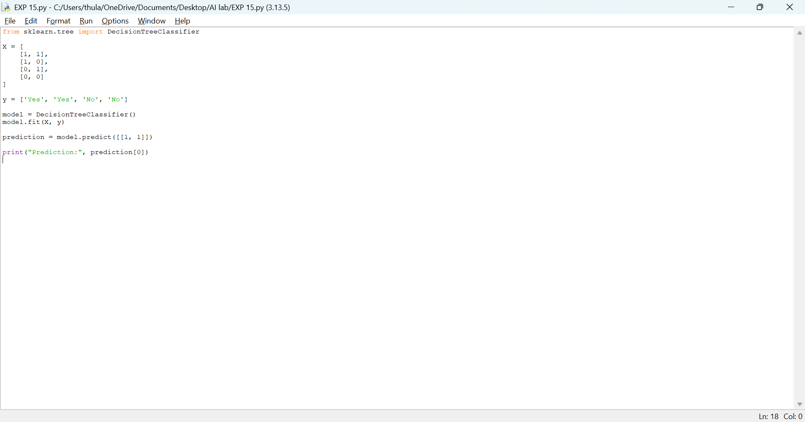

Output

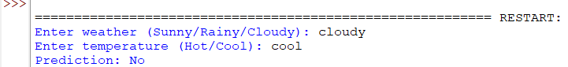

Result
Thus, the Decision Tree was implemented successfully using Python without external libraries.

